Welcome to Aveen International, a leading global organization specializing in the pharmacy and retail sectors. With a strong commitment to excellence and customer satisfaction, we offer a comprehensive range of services and solutions tailored to meet the needs of our customers in the Health Sector and retail industries

▪ AVEEN HEALTHCARE (AVEEN PHARMACY)



Aveen Pharmacy is a company dedicated to empowering individuals to live their healthiest and most fulfilling lives. Our mission is to provide comprehensive healthcare, retail products, and services that are accessible, affordable, and delivered with empathy. Our goals include providing high-quality goods and services, utilizing innovative technology, and continuously improving our offerings to meet the changing needs of our customers and communities. At Aveen, we are committed to being a leader in the healthcare and retail industries, setting a high standard for quality, innovation, and customer satisfaction.

We strive to bring the following services to your doorstep

1. Primary Healthcare Services: basic check-ups

2. Secondary Healthcare Services: specialist consultations and diagnostic tests

3. Retail Services: sale of authentic medicines and healthcare products

5. Telemedicine Services: virtual consultations and remote monitoring

6. Health and Wellness Programs: lifestyle and diet advice, stress management, and disease prevention

7. Clinical Research: conducting studies to improve patient outcomes and advance medical knowledge

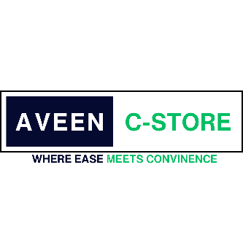▪ AVEEN RETAIL (AVEEN C-STORE)

* Product Sales: Aveen Retails offers a diverse selection of products across various categories, including Grocery, Confectionery and Bakery Items,Natrual Products Beauty and Care, staff members are available to assist customers with product inquiries, recommendations, and any other assistance required during the shopping experience.
  + - * E-commerce: In addition to physical stores, Aveen Retails operates an online platform that enables customers to conveniently shop from the comfort of their homes. The e-commerce website provides a user-friendly interface, secure payment options, and reliable delivery services.
      * Loyalty Programs: Aveen Retails offers loyalty programs to reward regular customers. These programs typically involve exclusive discounts, special promotions, and personalized offers that enhance the overall shopping experience and provide incentives for customer loyalty.
      * Gift Cards: Aveen Retails offers gift cards that can be purchased and used for shopping in their stores or on their e-commerce platform. These gift cards make for a convenient and versatile gifting option for various occasions
      * Return and Exchange Policy: Aveen Retails has a well-defined return and exchange policy to ensure customer satisfaction. Customers can easily return or exchange products within a specified time frame, provided they meet the required conditions.

AVEEN INTERNATIONAL DISTRIBUTORS

• Distribution and Supply Chain Management: We offer end-to-end distribution and supply chain solutions, ensuring the seamless flow of pharmaceutical products from manufacturers to pharmacies, hospitals, and healthcare institutions.

• Quality Assurance: We implement stringent quality assurance processes to uphold the highest standards in pharmaceutical distribution, ensuring the integrity and safety of the products we handle

Medical Equipment and Supplies: supply of medical equipment and consumables to healthcare providers

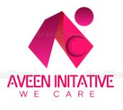

**AVEEN INITIATIVE**

The Aveen Initiative is a non-profit organization dedicated to addressing crucial issues in healthcare and food security. , The Segment operates with the primary goal of improving the lives of individuals and communities by ensuring access to quality healthcare services and promoting food sustainability.

Community Outreach: providing health education and promotion to underprivileged communities.

**Access to Healthcare**

The Aveen Initiative focuses on increasing access to healthcare services for underserved populations

**Medical Infrastructure Development**

The organization will collaborate with local communities and partners to develop and strengthen medical infrastructure in underserved regions

**Capacity Building and Training:**

Recognizing the importance of skilled healthcare workers, the Aveen Initiative provides training programs and capacity-building initiatives for medical professionals, nurses, and other healthcare personnel

**Food Distribution and Nutrition**: To address food scarcity and malnutrition, the organization implements programs that ensure equitable distribution of food resources

We look forward to the opportunity to serve you and address your pharmacy and retail needs.

Choose Aveen International Group as your trusted partner in pharmacy and retail, and experience the difference our expertise can make in driving your success.